

E-commerce Volunteer

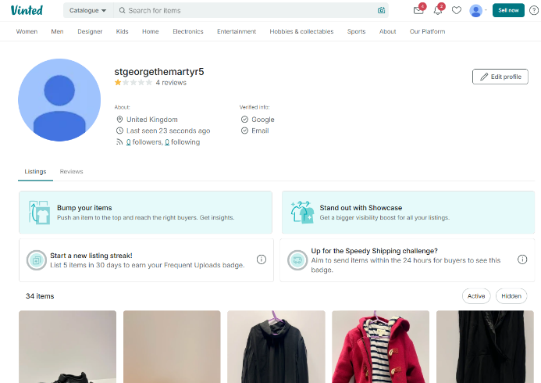
If you know your Depop from your Vinted, we need your help!

At St George the Martyr Queen Square we have a range of goods that have been donated to us to sell.

Could you use your online selling prowess to help raise much needed funds for the church?

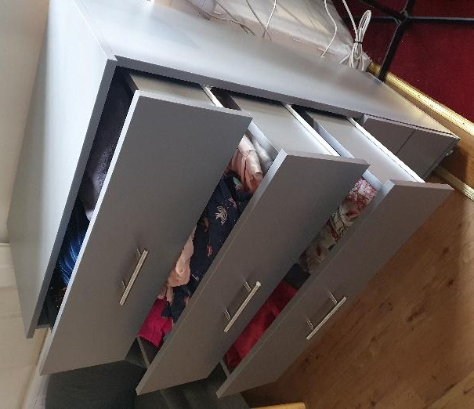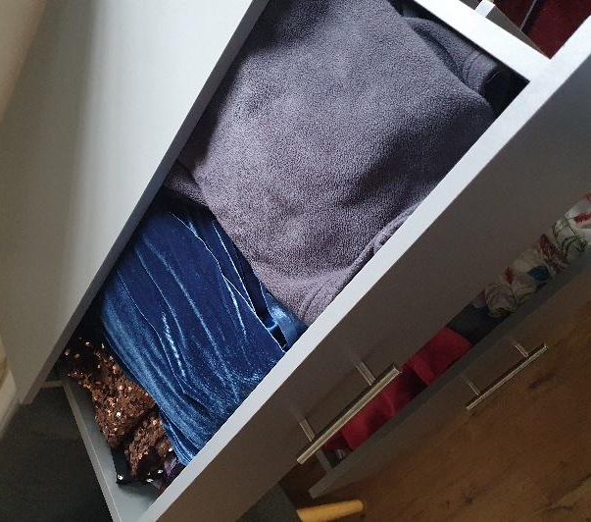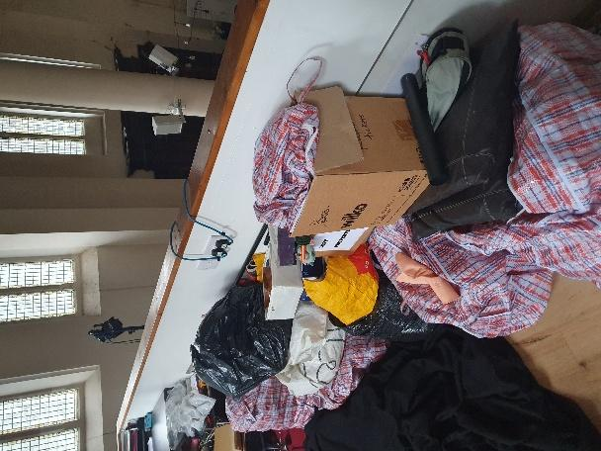

We need someone to
- select, sort, and price donated stock
- research valuable and vintage stock
- photograph and list items for online sale
- describe items for online listings
- prepare items for postage and dispatch

The role is very flexible - you can volunteer for a few hours a week or blitz it all in one block of time. The stock is in the church so you’ll need to be there for sorting and dispatching but can do the online stuff wherever you want. You will need your own phone and/or laptop.

If you are an online sales whizz and want to help, please contact Abi Morris, Client Project Manager, abi@sgtm.org

