
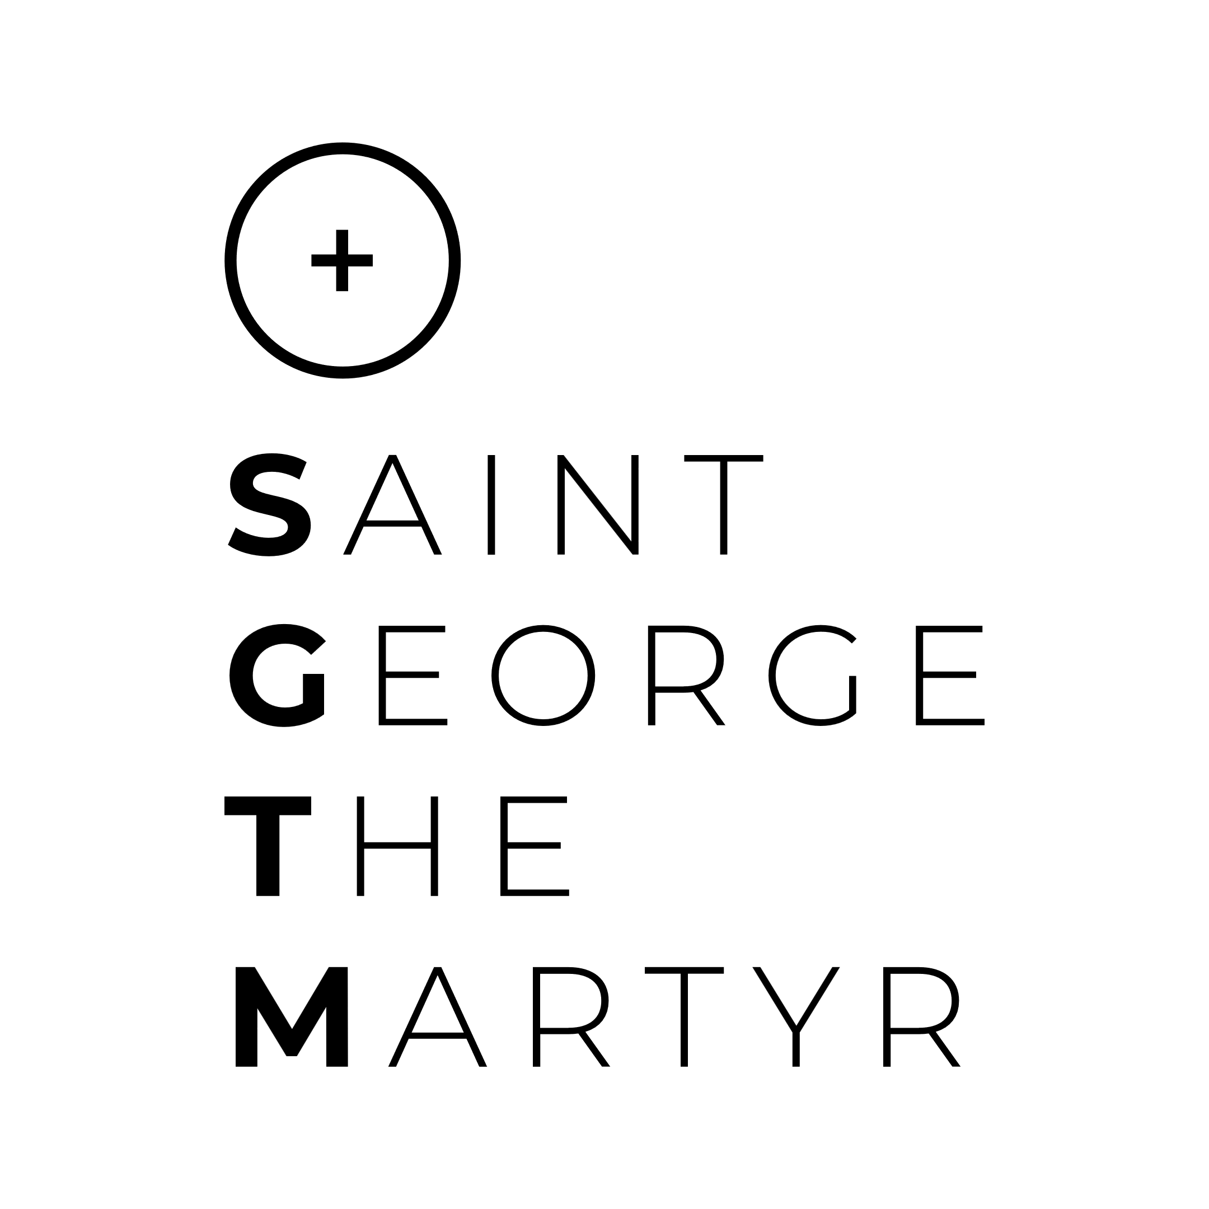
Events Volunteer
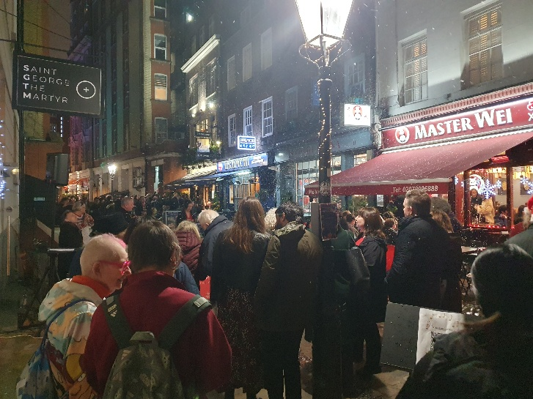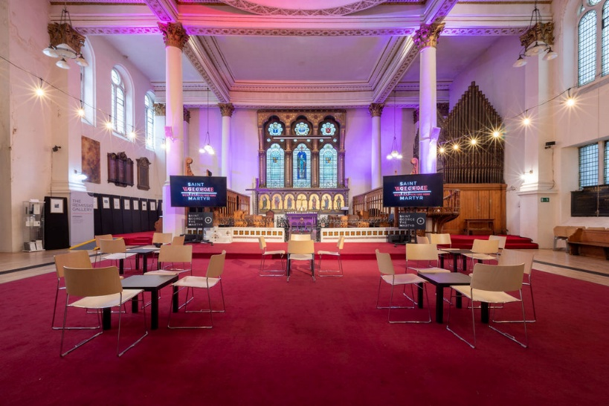
If you love meeting people and putting your organisational and problem-solving skills to great use, we need your help!

At St George the Martyr church we host a wide range of activities and events that are vital to the life of the church and its sustainability. The Events Volunteers are key to making sure our events and activities run smoothly and everyone has a great time.

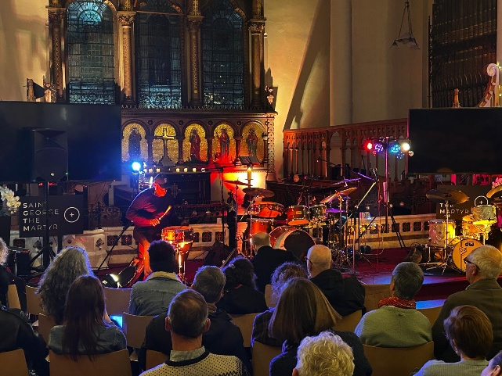
We need someone to:
- setup and pack-down: set up chairs, tables, equipment, decorations, and signage, pack up and clear the site afterwards
- welcome and greet visitors, providing directions and information, managing ticket or entry points, and assisting with customer service issues
- make and serve drinks

You’ll be happy volunteering at the church or near-by venues, or outside around the church and in Queen Square, and can commit to as many or as few event/activity days that suit you.

If you want to help, please contact Sally Jones, Families Pastor, office@sgtm.org

